**Task- 1**

**Aim: Create an app as shown in below image.**

**Program:**

import 'package:flutter/material.dart';

void main() {

runApp(

MaterialApp(

debugShowCheckedModeBanner: false,

home: Scaffold(

appBar: AppBar(

title: const Text("My APP"),

backgroundColor: Colors.lightGreen,

centerTitle: true,

),

body: Align(

alignment: Alignment.center,

child: Container(

color: Colors.lightGreen.shade600,

child: Center(

child: Container(

width: 320,

height: 320,

color: Colors.green,

alignment: Alignment.center,

child: Container(

width: 265,

height: 265,

alignment: Alignment.center,

color: Colors.lightGreenAccent,

child: const Text(

"oooo",

style: TextStyle(

fontSize: 170,

fontWeight: FontWeight.w300,

letterSpacing: -42,

color: Colors.black54,

),

),

),

),

),

),

),

),

),

);

}

**Output:**

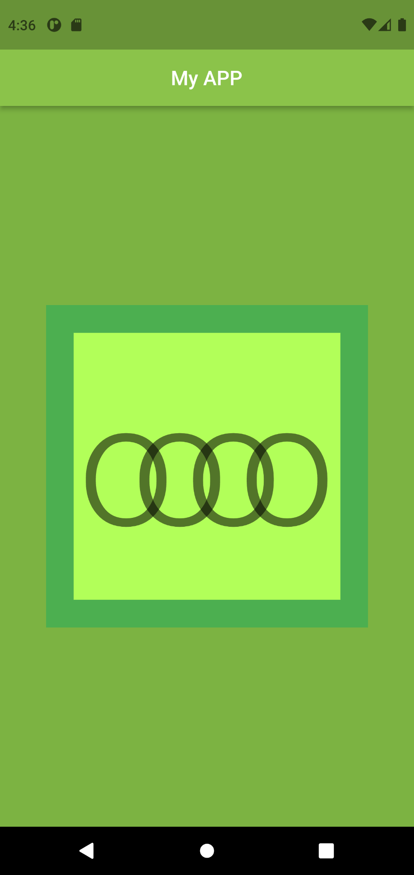

**Task- 2**

**Aim: Create an app as shown in below image.**

**Program:**

import 'package:flutter/material.dart';

void main() {

runApp(

MaterialApp(

debugShowCheckedModeBanner: false,

home: Scaffold(

appBar: AppBar(

title: Text("Mission of RNW"),

centerTitle: true,

backgroundColor: Colors.redAccent,

),

body: Align(

alignment: Alignment.center,

child: Container(

width: 350,

height: 110,

color: Colors.redAccent,

alignment: Alignment.centerRight,

child: Container(

width: 340,

height: 110,

color: const Color(0xffffcdc2),

child: Center(

child: RichText(

text: const TextSpan(

text: 'Shaping "skills" for "scaling" higher\n',

style: TextStyle(

color: Colors.black,

fontWeight: FontWeight.bold,

fontSize: 20,

height: 1.2,

),

children: [

TextSpan(

text: "- RNW",

style: TextStyle(

fontWeight: FontWeight.normal,

fontSize: 22,

),

),

],

),

),

),

),

),

),

),

),

);

}

**Output:**

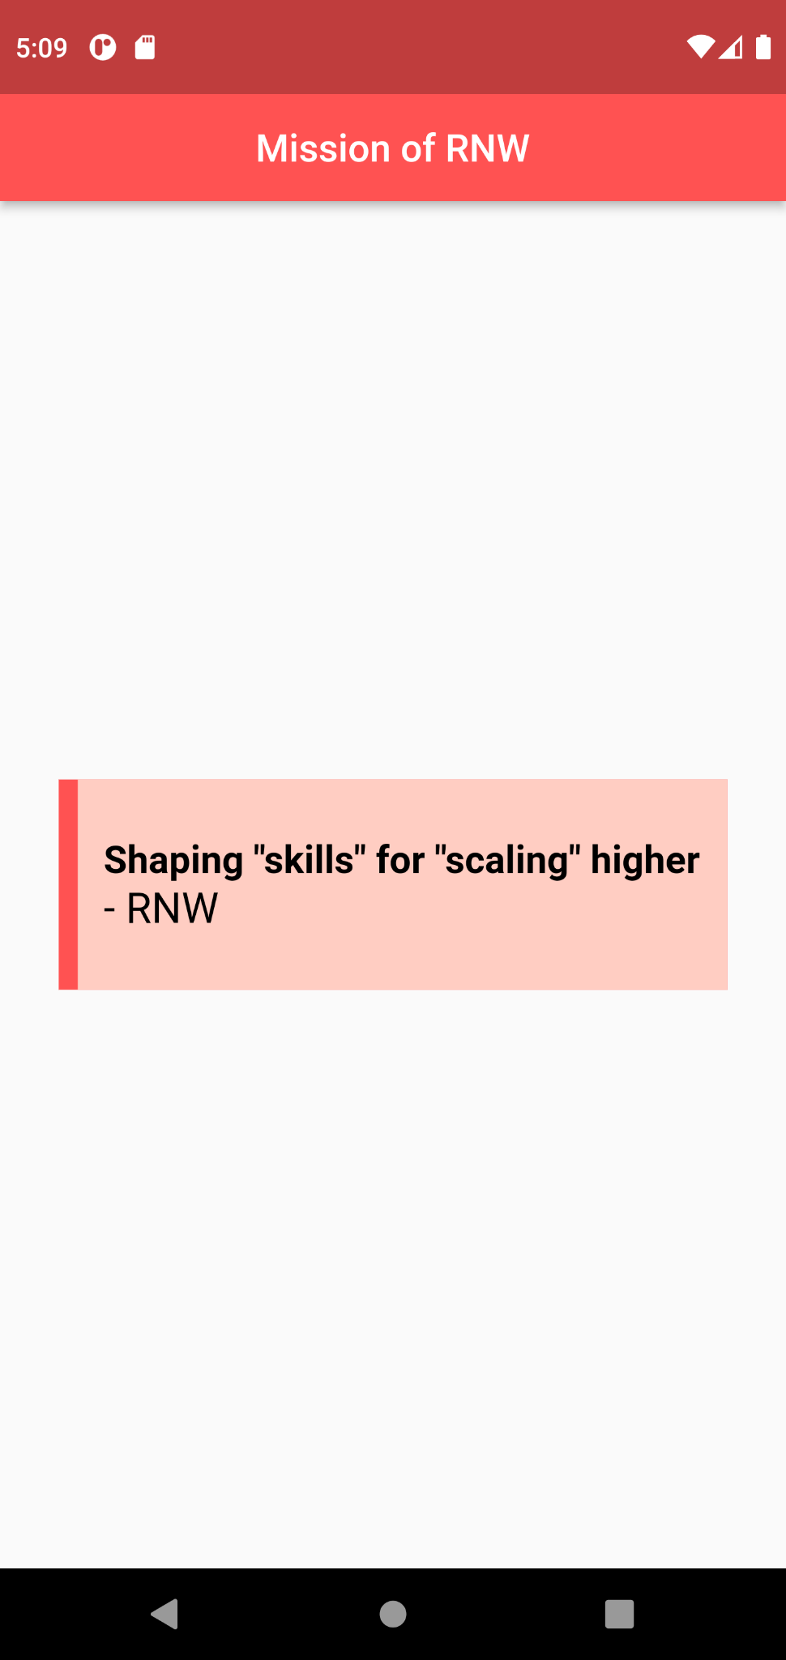

**Task- 3**

**Aim: Create an app as shown in below image.**

**Program:**

import 'package:flutter/material.dart';

void main() {

runApp(

MaterialApp(

debugShowCheckedModeBanner: false,

home: Scaffold(

appBar: AppBar(

title: Text("Mix-up"),

centerTitle: true,

backgroundColor: Colors.redAccent,

),

body: Align(

alignment: Alignment.center,

child: Container(

width: 430,

height: 430,

color: Colors.blue,

alignment: Alignment.bottomRight,

child: Container(

width: 340,

height: 380,

color: Colors.yellowAccent,

alignment: Alignment.bottomRight,

child: Container(

width: 290,

height: 330,

color: Colors.pink,

alignment: Alignment.topLeft,

child: Container(

width: 230,

height: 270,

color: Colors.orange,

alignment: Alignment.topLeft,

child: Container(

width: 175,

height: 215,

color: Colors.green,

child: Center(

child: Container(

width: 140,

height: 148,

color: Colors.tealAccent,

),

),

),

),

),

),

),

),

),

),

);

}

**Output:**

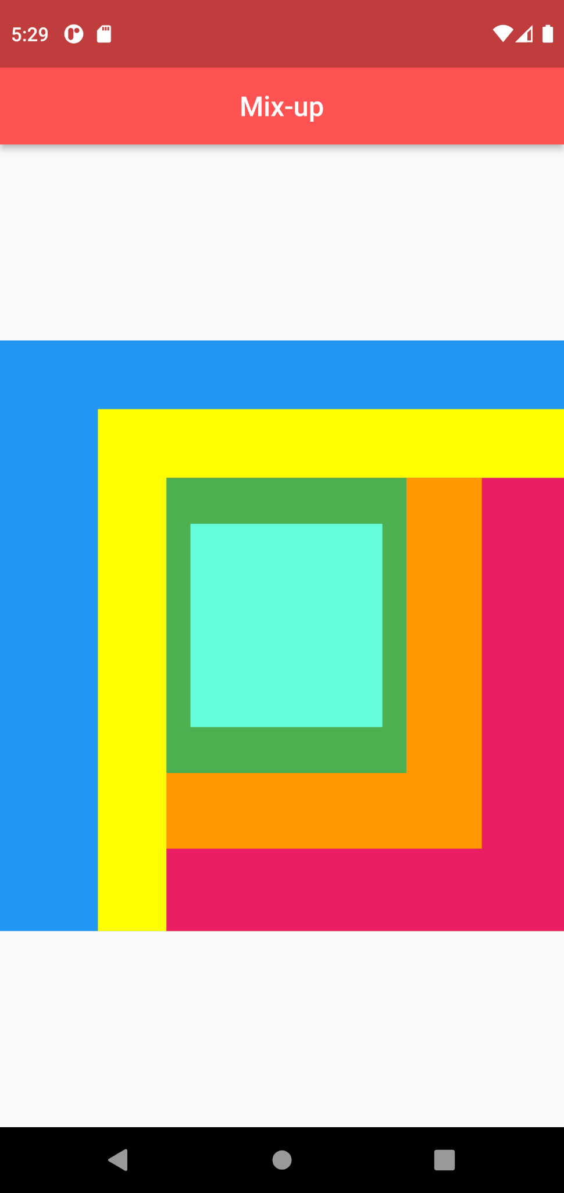

**Task- 4**

**Aim: Create an app as shown in below image.**

**Program:**

import 'package:flutter/material.dart';

void main() {

runApp(

MaterialApp(

debugShowCheckedModeBanner: false,

home: Scaffold(

appBar: AppBar(

title: const Text("Mashal"),

centerTitle: true,

backgroundColor: Colors.brown,

),

body: Align(

alignment: Alignment.center,

child: Container(

width: 100,

height: 130,

decoration: BoxDecoration(

color: Colors.brown,

border: Border.symmetric(

horizontal: BorderSide(

color: Colors.brown.shade400,

width: 15,

),

vertical: const BorderSide(

color: Colors.white,

width: 30,

),

),

),

alignment: const Alignment(0, -2.8),

child: const Text(

"🔥",

style: TextStyle(fontSize: 35),

),

),

),

),

),

);

}

**Output:**

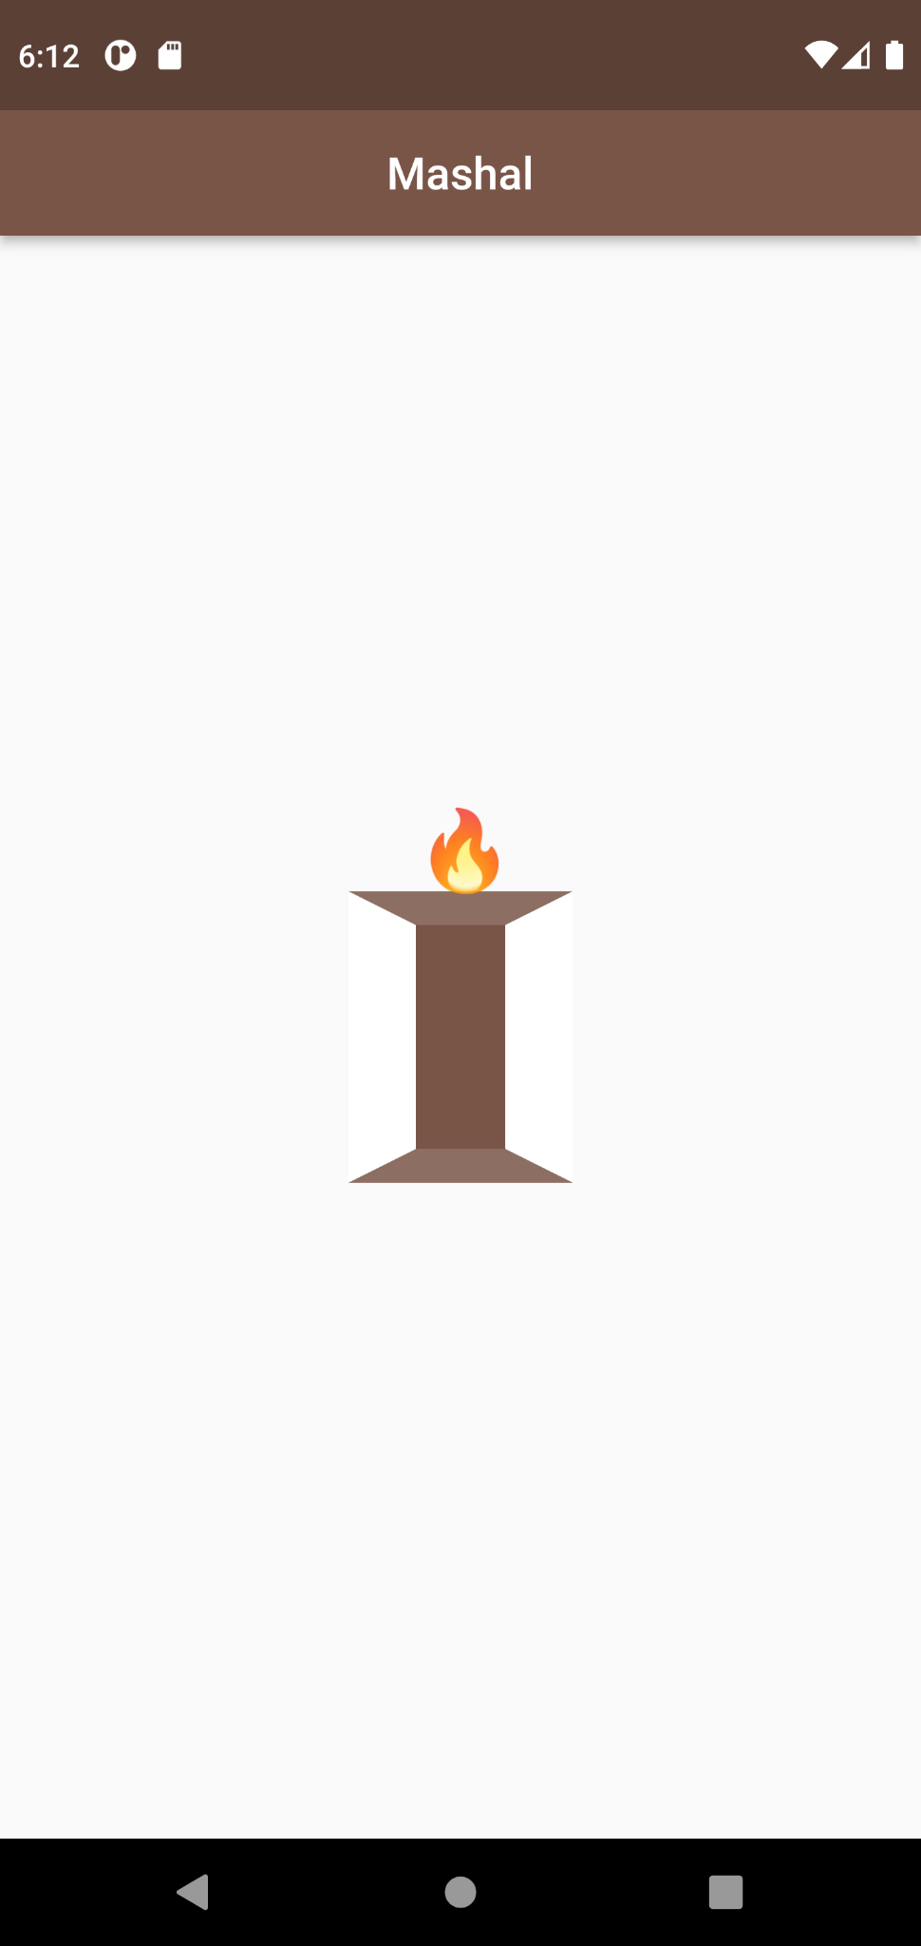

**Task- 5**

**Aim: Create an app as shown in below image.**

**Program:**

import 'package:flutter/material.dart';

void main() {

runApp(

MaterialApp(

debugShowCheckedModeBanner: false,

home: Scaffold(

appBar: AppBar(

title: const Text("Letter Cover"),

centerTitle: true,

backgroundColor: Colors.green,

),

body: Align(

alignment: Alignment.center,

child: Container(

width: 275,

height: 275,

decoration: BoxDecoration(

color: Colors.green,

border: Border.symmetric(

horizontal: BorderSide(

color: Colors.green.shade300,

width: 118,

),

vertical: const BorderSide(

color: Colors.green,

width: 118,

),

),

),

),

),

),

),

);

}

**Output:**

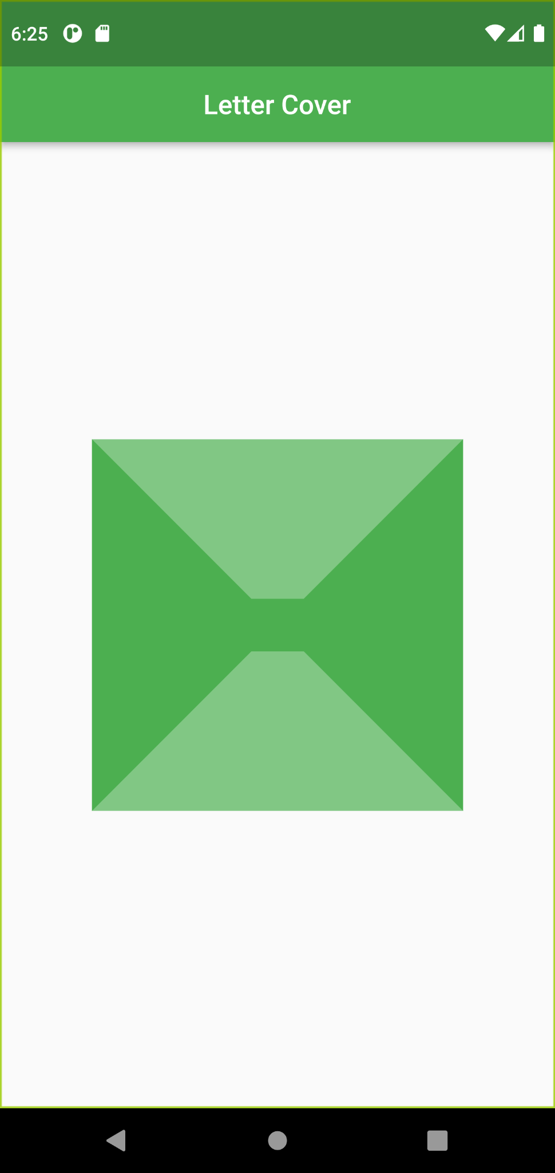

**Task- 6**

**Aim: Create an app as shown in below image.**

**Program:**

import 'package:flutter/material.dart';

void main() {

runApp(

MaterialApp(

debugShowCheckedModeBanner: false,

home: Scaffold(

appBar: AppBar(

title: const Text("3D Cube"),

centerTitle: true,

backgroundColor: Colors.teal,

),

body: Align(

alignment: Alignment.center,

child: Container(

width: 225,

height: 225,

decoration: BoxDecoration(

color: Colors.teal,

border: Border.symmetric(

horizontal: BorderSide(

color: Colors.teal.shade300,

width: 35,

),

vertical: BorderSide(

color: Colors.teal.shade400,

width: 40,

),

),

),

),

),

),

),

);

}

**Output:**

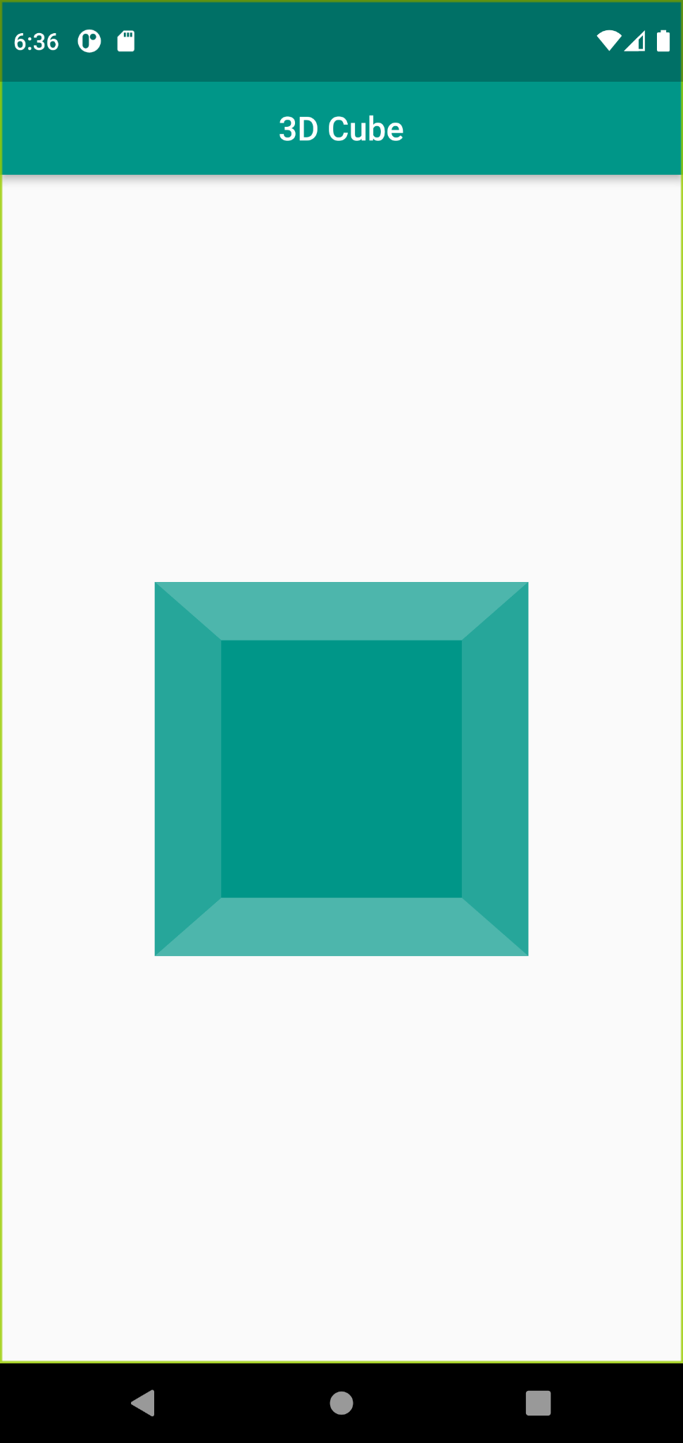

**Task- 7**

**Aim: Create an app as shown in below image.**

**Program:**

import 'package:flutter/material.dart';

void main() {

runApp(

MaterialApp(

debugShowCheckedModeBanner: false,

home: Scaffold(

appBar: AppBar(

title: const Text("Opened Doors"),

centerTitle: true,

backgroundColor: Colors.black,

),

body: Align(

alignment: Alignment.center,

child: Container(

width: 220,

height: 220,

decoration: const BoxDecoration(

color: Colors.black,

border: Border.symmetric(

horizontal: BorderSide(

color: Colors.black,

width: 30,

),

vertical: BorderSide(

color: Colors.white70,

width: 70,

),

),

),

),

),

),

),

);

}

**Output:**

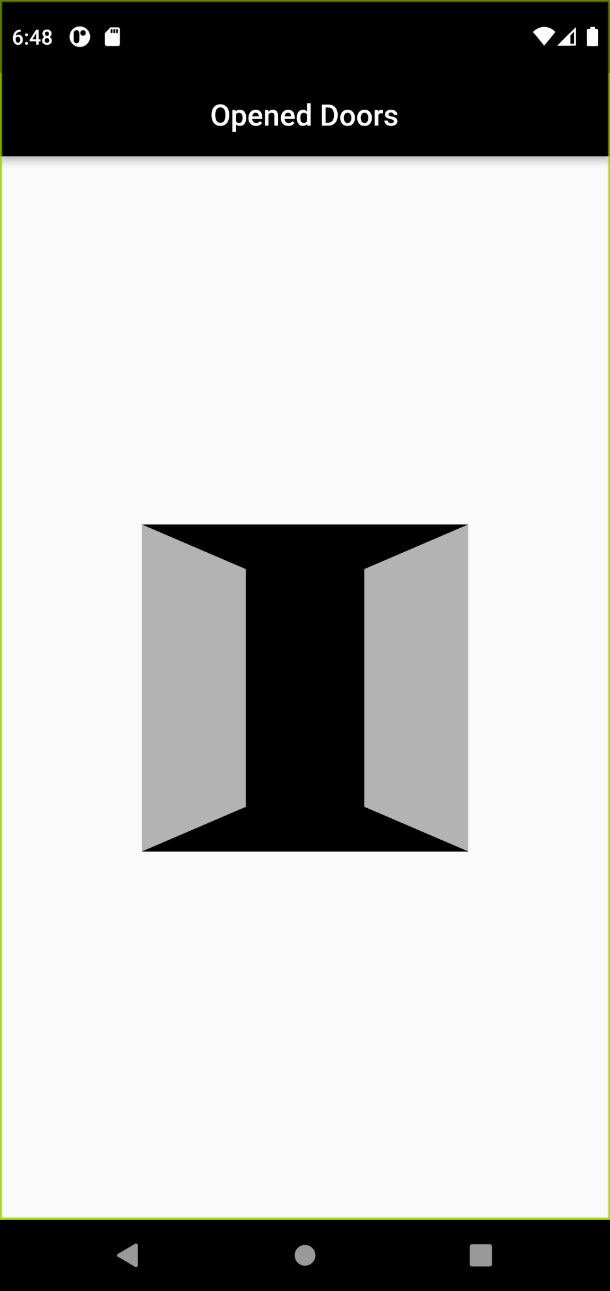

**Task- 8**

**Aim: Create an app as shown in below image.**

**Program:**

import 'package:flutter/material.dart';

void main() {

runApp(

MaterialApp(

debugShowCheckedModeBanner: false,

home: Scaffold(

bottomNavigationBar: BottomAppBar(

child: Container(

height: 60,

width: 400,

color: Colors.orange,

child: const Text(

"Emoji",

style: TextStyle(

fontSize: 25,

color: Colors.white,

),

),

alignment: Alignment.center,

),

),

body: Align(

alignment: Alignment.center,

child: Container(

width: 300,

height: 300,

child: Container(

decoration: const BoxDecoration(

shape: BoxShape.circle,

color: Colors.orange,

),

alignment: Alignment.topCenter, //alignment: Alignment(1, 1),

child: Container(

width: 230,

height: 295,

child: Container(

decoration: const BoxDecoration(

shape: BoxShape.circle,

color: Colors.white,

),

alignment: Alignment(1.1, -1.1),

child: Container(

width: 235,

height: 260,

child: Container(

decoration: const BoxDecoration(

shape: BoxShape.circle,

color: Colors.orange,

),

alignment: const Alignment(-0.6, 0),

child: Align(

alignment: Alignment(-0.6, 0),

child: Container(

width: 70,

height: 70,

decoration: const BoxDecoration(

shape: BoxShape.circle,

color: Colors.white,

),

child: Align(

alignment: const Alignment(2000, 0),

child: Container(

width: 69.9,

height: 69.9,

decoration: const BoxDecoration(

shape: BoxShape.circle,

color: Colors.white,

),

),

),

),

),

),

),

),

),

),

),

),

),

),

);

}

**Output:**

